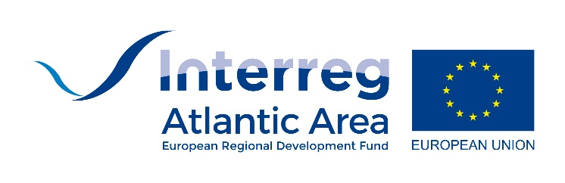
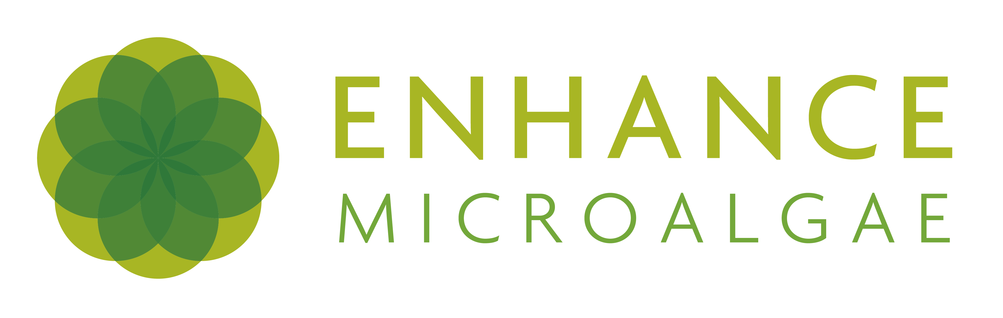
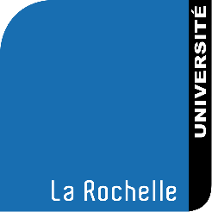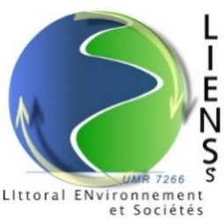

Job description: PhD position 3 years UMRi CNRS7266 LIENSs La Rochelle University France
Date: September 2021 September 2024
Salary (gross): approximatively 1500-1700 €.
PhD supervisor: Dr. Laurent PICOT, Senior Lecturer in Biochemistry, La Rochelle University, UMRi CNRS 7266 LIENSs, BCBS team (https://lienss.univ-larochelle.fr/Picot-Laurent)
Operating budget: Part of the operating budget is provided by the European Interreg EnhanceMicroalgae EAPA338_2016 project https://www.enhancemicroalgae.eu/ “High-added value industrial opportunities for microalgae in the Atlantic Area”, part by the CNRS
Thesis subject: Identification of anti-cancer and anti-viral enzyme inhibitors from coastal, terrestrial plants and algae using a magnetic bead-grafted enzyme ligand capture strategy
Despite the progress made in recent decades in cancer biology and targeted therapies, this disease remains the second leading cause of death in the world. In particular, therapeutic limits still exist for the most aggressive chemoresistant forms such as metastatic melanoma. Similarly, viral infections affect a significant proportion of the world's population and the current pandemic of COVID-19 reminds us of the urgent need to identify innovative active compounds to develop effective antiviral drugs.
Coastal plants and marine organisms, particularly micro- and macro-algae, have developed an arsenal of cytotoxic and allelopathic secondary metabolites that represent an original and still little explored source of active anticancer and antiviral molecules. Some have antiviral or cytotoxic activities, although the molecules responsible for these activities have not been clearly identified. They contain a wide variety of heterocycles, bioactive lipids, terpenes, acetogenins, polyphenols, halogenated or sulphated compounds and pigments that may target key enzymes in tumorigenesis or viral proliferation processes. The main current challenge is therefore to screen and purify these active ingredients efficiently and rapidly from complex matrices.
The PhD student will develop an innovative ligand fishing technique using extracts from plants and algae to identify selective inhibitors of key enzymes involved in tumour proliferation, chemoresistance and viral particle assembly. The objective is to immobilise target enzymes (BRAF kinase, sphingosine kinases 1 and 2, topoisomerases I and II and SARS-COV-2 protease 3CL) on magnetic microbeads and then affinity purify natural molecules that bind specifically to these enzymes by separating them from their matrix by magnetic sorting.
Initially, the proof of concept of the strategy will be carried out with known ligands of the enzymes, then algal and plant extracts will be screened to capture original molecules. Molecules will be eluted by ionic strength enhancement or competition with known ligands and characterised by high resolution mass spectrometry and NMR. The purified molecules will be evaluated for their ability to inhibit enzymes, cancer cell growth and viral replication in vitro.
This project is part of the BCBS team's theme 2 "Bioactive natural substances with anticancer activity: Pigments and heterocycles", lead by the PhD supervisor. It will contribute to the knowledge of the chemodiversity of coastal plants and algae, and should lead to the development of new anti-cancer and anti-viral drugs.
The thesis work will include the following steps
1) Conduct a literature review of all studies using ligand fishing techniques, in order to write a review and select the best strategy for enzymatic coupling to magnetic beads. Identify candidate species with the greatest potential for anti-cancer and anti-viral drug identification.
2) Validate the proof of concept of ligand fishing on selected enzyme targets, using known ligands diluted in complex matrices.
3) Identify novel enzyme inhibitors in plant, micro- and macro-algae extracts and validate their in vitro activity on melanoma cells and viral infection models in collaboration with partner laboratories working with various viral models. A preclinical study will be carried out depending on the results and the budget, to validate the in vivo activity of active compounds.
The PhD project will be carried out in partnership with international labs, including one CNRS pharmacognosy laboratory in Paris (UMR 8038 CITCOM Paris University, Dr Raphaël Grougnet), the plant pharmacognosy laboratory of UNIVASF Petrolina, PE-Brazil (Núcleo de Estudos e Pesquisas de Plantas Medicinais, Pr Jackson Guedes da Silva Almeida), the Laboratory of Marine Biotechnology and Marine Chemistry (LBCM Vannes, France, Pr Nathalie Bourgougnon) and Havana University in Cuba (Dr idania Rodeiro-Guerra and Liena de Regla-Ponce).

Required skills and experience
Master 2 in Organic chemistry, Phytochemistry, Natural products, knowledge in plant and algae pharmacognosy
Experience in the field of natural products extraction, purification, and structural characterisation of complex natural molecules is compulsory (NMR, mass spectrometry)
Scientific rigour and creativity
Previous publication of scientific results will be appreciated
A knowledge of pharmacological techniques (eukaryotic cell culture, western-blot, cytoskeleton studies, optical and fluorescence microscopy) will be appreciated although the candidate may be fully trained in these techniques during his/her thesis
French and English are compulsory (level B2 in English will be appreciated).
Fluency to present research work at conferences and integrate an interdisciplinary and international team (chemists, biochemists, pharmacologists)

BCBS team and UMRi CNRS 7266 LIENSs laboratory
BCBS team https://lienss.univ-larochelle.fr/BCBS-Biotechnologies-and-Chemistry-applied-to-Bioresources-for-Health (Director Pr. Thierry Maugard)
The team gathers teacher-researchers belonging to different disciplines: biochemistry, molecular biology, enzymatic engineering, microbial biochemistry and organic chemistry. The team activity, which is embedded in a biology-chemistry interface, relates to biotechnological and chemical exploitation of natural resources (marine and agricultural) in order to obtain and create products and services ensuring preservation and well-being of health populations. The team applies its research in pharmaceutical, therapeutic, health-nutrition, dermo-cosmetic’s fields, and collaborates closely with industrial partners from the field of new ingredients or supplements for food and human health. Resolutely turned towards innovation and technology transfer, the team also aligns its development in interaction with the socioeconomic sphere, firstly by highlighting its academic research activities next to it, then by answering to exogenous requests. That is why the team is particularly associated with the biotechnology chair entitled Bioaqtiv’, that proposes several specialized technological services for companies in the area of health biotechnologies and agrifood.
Team Skills:
- Organic synthesis
- Biomolecules extraction and purification
- Proteins and peptides biochemistry
- Sugar biochemistry
- Molecular enzymology
- Microbial biochemistry
- Metabolic biochemistry
- Cellular biology
- Molecular biology
- Protocol development for experiments with animal models
Application fields: fine chemistry, human and animal health, pharmaceutical industry, environment, animal production, nutrition, agro-industry, cosmetic industry, bioenergy.
Representative publications by the PhD supervisor
Gonçalves de Oliveira Junior R., Grougnet R., Bodet P.E., Bonnet A., Nicolau E., Jebali A., Rumin J., Picot L. Updated pigment composition of Tisochrysis lutea and purification of fucoxanthin using centrifugal partition chromatography coupled to flash chromatography for the chemosensitization of melanoma cells. Algal research 51, 102035, 2020.
Gonçalves de Oliveira Junior R., Marcoult-Freville N., Prunier G., Beaugeard L., Beserra de Alencar Filho E., Simões Mourão E.D., Quintans-Júnior L.J., Guedes da Silva Almeida J., Grougnet R., Picot L. Polymethoxyflavones from Gardenia oudiepe (Rubiaceae) induce cytoskeleton disruption-mediated apoptosis and sensitize BRAF-mutated melanoma cells to chemotherapy. Chemico-Biological Interactions 325, Article 109109, 2020.
Gonçalves de Oliveira Junior R., Nicolau E., Bonnet A., Prunier G., Beaugeard L., Joguet N., Thiéry V., Picot L. Carotenoids from Rhodomonas salina induce apoptosis and chemosensitization of human melanoma cells to vemurafenib and dacarbazine. Brazilian Journal of Pharmacognosy 30, 155-168, 2020.
Gonçalves de Oliveira Junior R., Bonnet A., Braconnier E., Groult H., Prunier G., Beaugeard L., Grougnet R., Guedes da Silva Almeida J.R., Alves Ferraz C.A., Picot L. Bixin, an apocarotenoid isolated from Bixa orellana L., sensitizes human melanoma cells to dacarbazine-induced apoptosis through ROS-mediated cytotoxicity. Food and Chemical Toxicology 125, 549-561, 2019.

LIENSs lab https://lienss.univ-larochelle.fr/?lang=en
LIENSs is a join research unit under the CNRS and La Rochelle University authorities, which integrates expertises in many scientific fields within environmental sciences (biology, ecology, ecophysiology, ecotoxicology, earth sciences, geophysics), humanities and social sciences (geography and history), and Engineering Sciences (chemistry and biotechnology). It takes strength through a high interdisciplinarity to address issues on the sustainable development of its main research object : the littoral zone.
LIENSs was established in 2008 as part of a larger project aiming at developing at La Rochelle research and education on the Environment and Sustainable Development. This included the setting up of a Research Federation (FREDD), presently extended to the regional scale, that brings together 22 laboratories to sustain this thematics, and of a Doctoral School (Gay-Lussac Doctoral School) involving 3 Universities (La Rochelle, Poitiers, Limoges).
LIENSs is one of the 2 first units to be jointly supported by 3 CNRS Institutes (INEE, INSU, INSHS) as a recognition of its large interdisciplinarity, developed by 6 teams working on their core disciplinary thematics, but also on numerous common projects, some being set up as cross-axes.
LIENSs presently comprises 69 researchers/lecturer-researchers, 28 permanent engineers/technicians, 24 post-docs and invited researchers, 10 contracted technical staff and 32 PhD students.
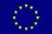
LIENSs research activities largely benefit from local authorities fundings, through research programs at regional, national and European -levels and from specific European fundings (FEDER) within the CPER 2007-2013 (Contracted Projects State-Region).
The research unit LIENSs, established on January 1, 2008, was created by joining 4 laboratories concerned by various disciplinary fields : Humanities and Social Sciences, Environmental Sciences and Engineering Sciences, focusing mainly on one object under study : the littoral zone.
LIENSs presently includes 6 research teams :
Approach by Geography : Islands, Littoral areas and Environment (AGILE)
Physical Dynamics of the Littoral zone (DPL)
DYnamics of the Functioning of coastal Ecosystems under Anthropic pressure (DYFEA)
Marine animals responses to environmental variability (AMARE)
Molecular Approaches, Environmental health (AMES) = BCBS
SpacEs, Societies, TerritoRies of Ancient and New shores (ESTRAN)
Four cross-axes (Coastline changes ; Status indices of littoral ecosystems ; Management and valuation of marine ressources ; Microbial biofilms) allow to develop integrated studies between teams and 2 methodological workgroups, Ecological tracers and GIS enable lab staff to develop up-to-date methods in these fields.
Resarch activities are supported by 9 analytical facilities managed by teams and 6 common analytical or logistical platforms.

Application guidelines:
Application procedure will close on the 31st of May 2021.
For applications to be valid, candidates must submit a letter of motivation, a free-format curriculum vitae (3 pages maximum) including a short abstract of the studies achieved during the Master 2 position (one half page maximum), a list of publications and two reference names and contact address. These documents have to be sent as pdf files to Dr Laurent Picot (laurent.picot@univ-lr.fr). Depending on the number of applications, people in charge of the recruitment will select a shortlist of candidates whose scientific profiles in their view met more closely the expected criteria. Once a shortlist has been finalized, all applicants will be notified of the status of their application. The final shortlist of candidates will then be invited to an interview (probably videoconference).

